Reability Main Application Installation Guide

You need to receive an installation zip file from your project manager and unzip it to a temp folder or your documents folder.

Open Terminal and navigate to your development folder (where all your projects are located).

Enter the following command:

ip a

locate in the printed output your ip address (marked in yellow below) and write it down so you will remember it and also send it by email to the project manager so he/she will be able to
enable you to run the app locally.

lo: <LOOPBACK,UP,LOWER_UP> mtu 65536 qdisc noqueue state UNKNOWN group default qlen 1000
link/loopback 00:00:00:00:00:00 brd 00:00:00:00:00:00
inet 127.0.0.1/8 scope host lo
valid_lft forever preferred_lft forever
inet6 ::1/128 scope host
valid_lft forever preferred_lft forever
2: enp1s0: <NO-CARRIER,BROADCAST,MULTICAST,UP> mtu 1500 qdisc fq_codel state DOWN group default qlen 1000
link/ether 68:f7:28:28:c6:55 brd ff:ff:ff:ff:ff:ff
3: wlp2s0: <BROADCAST,MULTICAST,UP,LOWER_UP> mtu 1500 qdisc noqueue state UP group default qlen 1000
link/ether d0:7e:35:3c:71:3e brd ff:ff:ff:ff:ff:ff
inet 192.168.10.97/24 brd 192.168.10.255 scope global dynamic noprefixroute wlp2s0
valid_lft 599509sec preferred_lft 599509sec
inet6 fe80::c8ae:3d4e:569a:b62a/64 scope link noprefixroute
valid_lft forever preferred_lft forever

Enter the following commands:

git clone git@bitbucket.org:spectory/reability-peerjs.git

git clone git@bitbucket.org:spectory/reability.git

Now you have 2 new projects in your projects folder: reability and reability-peerjs
Copy the .env file and the Cert folder from the peerjs cd peerfolder in the installation package to the main peerjs project

Open in text editor the .env file in the peerjs project

Change the value of “REABILITY_URL” to your ip addresses and save the file.

Navigate in the terminal to the peerjs project folder

Enter the following commands:

npm install

npm run start:development

You should see something like this :

> reability-peerjs@0.0.2 start:development /home/uzi/development/reability-peerjs
> NODE_ENV=development node app.js

You should always leave this terminal open !!!!
If you need the terminal, just open a new one.

Open your browser and navigate to:
https://192.168.10.97:3001/
(Change the ip address according to your ip).

You should see the following :
Cannot GET /

If you see a message “Your connection is not private”
click the “Advanced” button and then click on the link in the bottom of the screen that says “proceed to …..”

and then you should see the following
Cannot GET /

Now the peerjs project is ready

Copy the .env file from the reability folder in the installation package to the main reability project folder

Change the value of “SIGNALING_SERVER” to your ip addresses and save the file
SIGNALING_SERVER=192.168.10.97:3001

Change the value of “SERVER_URL” to your ip addresses and save the file
SERVER_URL=https://192.168.10.97:8080

Open the Reability Project in VS code

Open the following file: client/src/environments/environment.ts

Change the value of MY_IP to your ip and save

const MY_IP = ‘192.168.10.97’ // Uzi Office ip

Open The vs code terminal (Ctrl-j)

Enter the following commands:

asdf install nodejs 12.18.0

asdf local nodejs 12.18.0

npm install

cd client

npm install

cd ..

npm run db:init:dev
Open Valentina Studio and verify that you have the reability-dev db that has several tables
and have data in users table (9 records) with encrypted data

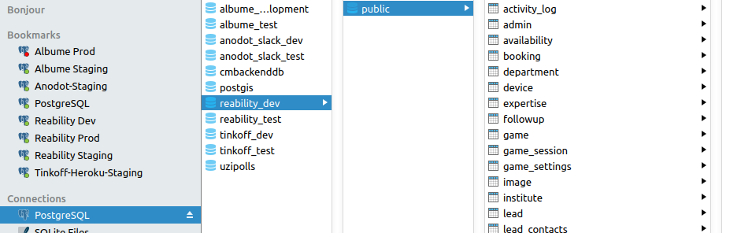

This how the users table should look like

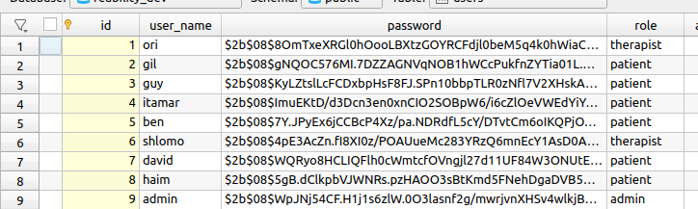

Open other 2 terminals in vs code by hitting the plus in the top right corner of the terminal window

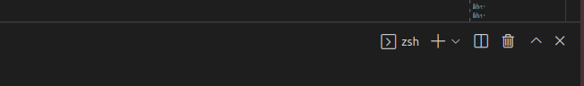
You will see a navigation between the terminals

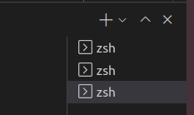

Navigate to one of the new terminals and enter the following:
npm run start:server

You should see something like this at the end of the process:

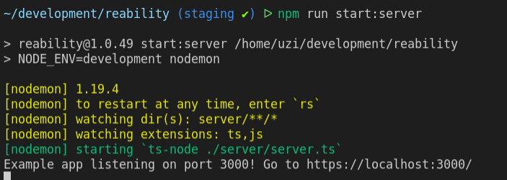
Navigate to the other terminal and enter the following

npm run start:client

You should see something like this :

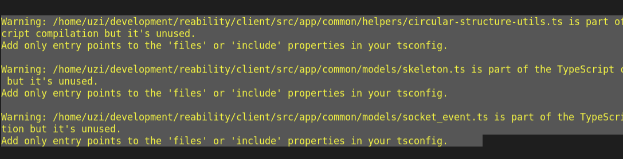

Open your web browser and navigate to the following address (Change the ip according to your ip)

https://192.168.10.97:8080/#/login

If you see a message “Your connection is not private”
click the “Advanced” button and then click on the link in the bottom of the screen that says “proceed to …..”

and then you should see the application login screen

In the application package there is a file called “local users” with all possible logins (usernames and passwords) that you can test the system with.

Try to login to patient and see that the app is working ok.

In addition before start developing please make sure that the following VS Code extentions are installed : Code Spell Checker, Git Blame, “GitLens-Git supercharged”, Material Icon Theme,
“Path Intellisense”, “Prettier – Code formatter”, “SCSS Formatter”, “TSLint”

